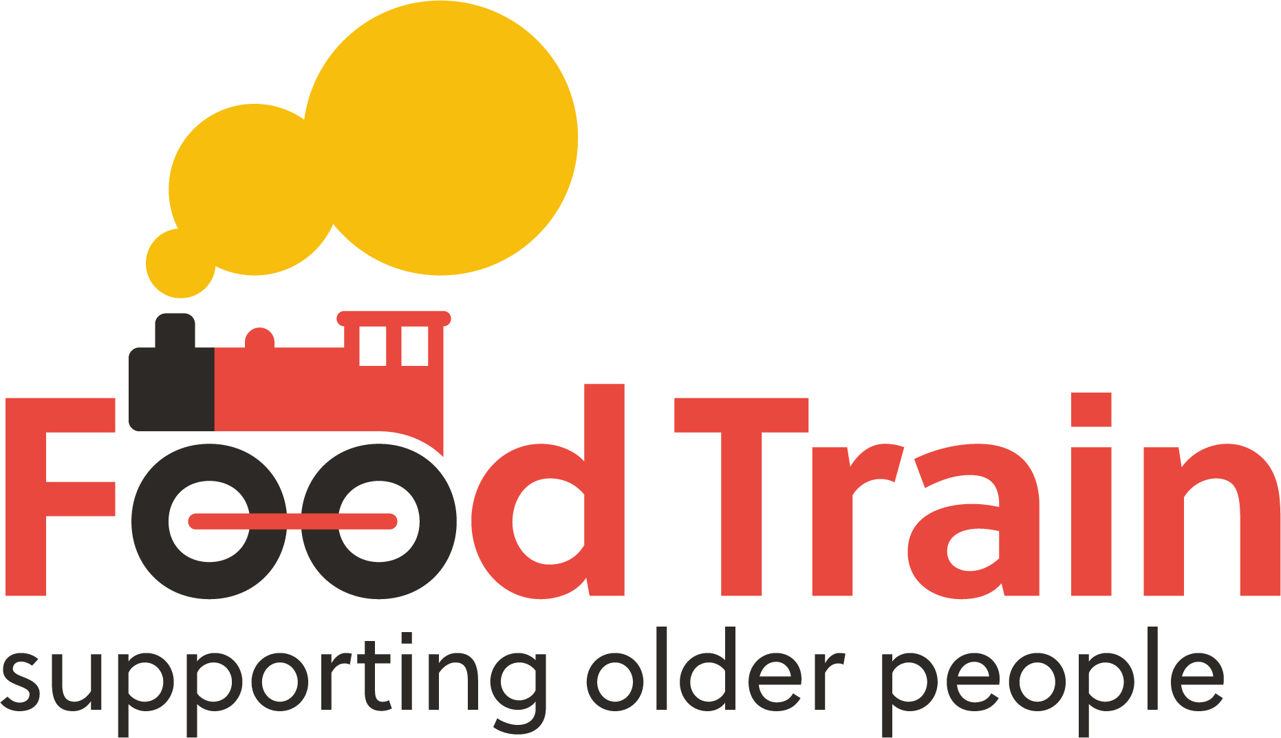

Job Description

Title: Development Officer (Meal Makers)

Salary Starting Point: £26,115 FTE plus pension and travel costs
Hours: Part time 24 hours per week
Responsible to: Regional Manager / National Operations Manager (Line Manager)

Contract: Permanent
Location: Home based / Based within any existing Food Train Branch. Travel to other branch offices may be required from time to time.

Practical Requirements
- current driving licence and access to a car for work purposes
- able to travel throughout the localities and region wide if required
- able to work flexible hours and location as required
- subject to a successful Protecting Vulnerable Groups Scheme Record check

Background to post: Food Train offers a range of services to support older across Scotland to live independently at home: a grocery shopping delivery service, befriending services, a practical household support service, a neighborhood meal sharing service (Meal Makers) and projects to improve nutritional health in older people. If you’d like to help create social change, improve the lives of older people, work alongside local volunteers, and help develop these services, then we’d love to hear from you.

Duties:
- Continue to develop the Meal Makers service for older people in Scotland, from service delivery through to assisting with other elements of the project as required
- Develop Meal Makers by growing member numbers, increasing the uptake of our range of services, work with Line Manager to pilot additional services and service models to enable growth for the sustained support of older people across Scotland.
- Responsible for overseeing accurate and timely collection of membership fees and service charges due.
- Build and maintain a volunteer group adequate in size for delivering the Meal Makers service by recruiting, training, supervising and supporting the volunteer team including regular 1-2-1 supervisory meetings with volunteer befrienders/ Cooks.
- Update and monitor a customer care and communication pipeline for ‘cooks’ and ‘diners’ that tracks relationships and gathers both statistical and outcome focused data for required reporting purposes
- Learn, understand and work specifically with the web platform mapping and matching ‘cooks’ and ‘diners’, following up on meal sharing data across all matches and maintain relationships with both ‘cooks’ and ‘diners’
- Make best use of social media and a wide range of marketing and communication tools to ensure potential ‘cooks’ of all backgrounds are included
- Make best use of existing Food Train relationships and networks to reach as many potential ‘diners’ and referring agencies as possible, establishing new relationships and networks to create the widest reach
- Work closely with the Project Administrator on information gathering, best practice use of the web platform whilst ensuring that information is used sensitively and in line with existing Food Train good practice
- link and liaise with Food Train staff, volunteers, partners and customers to ensure Meal Makers operates to Food Train quality and standards
- support Food Train’s leadership to ensure Meal Makers policy, procedures, pathways and best practice (and those of Food Train) are adhered to by all staff and volunteers working with the project
- Promote and maintain working links with other voluntary, statutory and community groups across Scotland in furtherance of our member and volunteer outcomes
- Undertake the Administrative tasks required including: manage petty cash, completing databases, gathering membership fees, , customer care based tasks, , producing reports and other general office duties as required
- agree and work to a range of project targets (with Line Manager)
- Any other duties as reasonably requested and related to the position

Person Specification ~ Essential
- You must be socially aware, passionate about eating well and driven by the desire to lead social change for people.
- There are no formal requirements for this role. However, experience working within a people based service delivery project working with volunteers is essential either within the voluntary sector or other relevant role.
- A keen interest, understanding and experience of bespoke computer programs and web platforms will be required.
- You must have good organisational skills, an excellent approach to problem solving, be skilled at creative thinking, planning and implementing and demonstrate a desire for success
- An excellent and talented communicator is required; you need to be a real ‘people person’ with a good sense of humour who can adapt to any situation and people from a wide cross sector of society and professions.
- Knowledge and experience of using work based social media and a wide range of marketing and promotional tools.
- Understanding and managing relationships internally and externally are critical in this position. Practice based experience of customer care focus and working with a wide range of people will be required.
- Experience of data gathering, monitoring and reporting with both a statistical and outcomes focus is essential to this post.
- You must be a motivated and enthusiastic individual, a real ‘go-getter’ who can work creatively, responsively and flexibly delivering on positive outcomes for our members, staff, volunteers, partners, funders and other key stakeholders.
- A high standard of administration, IT skills and knowledge of Microsoft Applications.

- Person Specification ~ Desirable, but not essential
- Practice based experience supporting older people
- Practice based knowledge of social care provision and the voluntary sector in Scotland will be most beneficial
- Knowledge and understanding of social enterprise ethos and principles
- Knowledge of local and national policies and care standards in relation to older people in Scotland
- Knowledge and understanding of Local Government and NHS structures, in particular Social Work Services and Health and Social Care

